**Project Deliverable 3**

**Team - 4**

**Abhinav Botla**

**Ajith Gannamaneni**

**Hrushikesh Dandge**

**Mitra Buggaveeti**

**Prateek Chanddra**

Installing the necessary packages

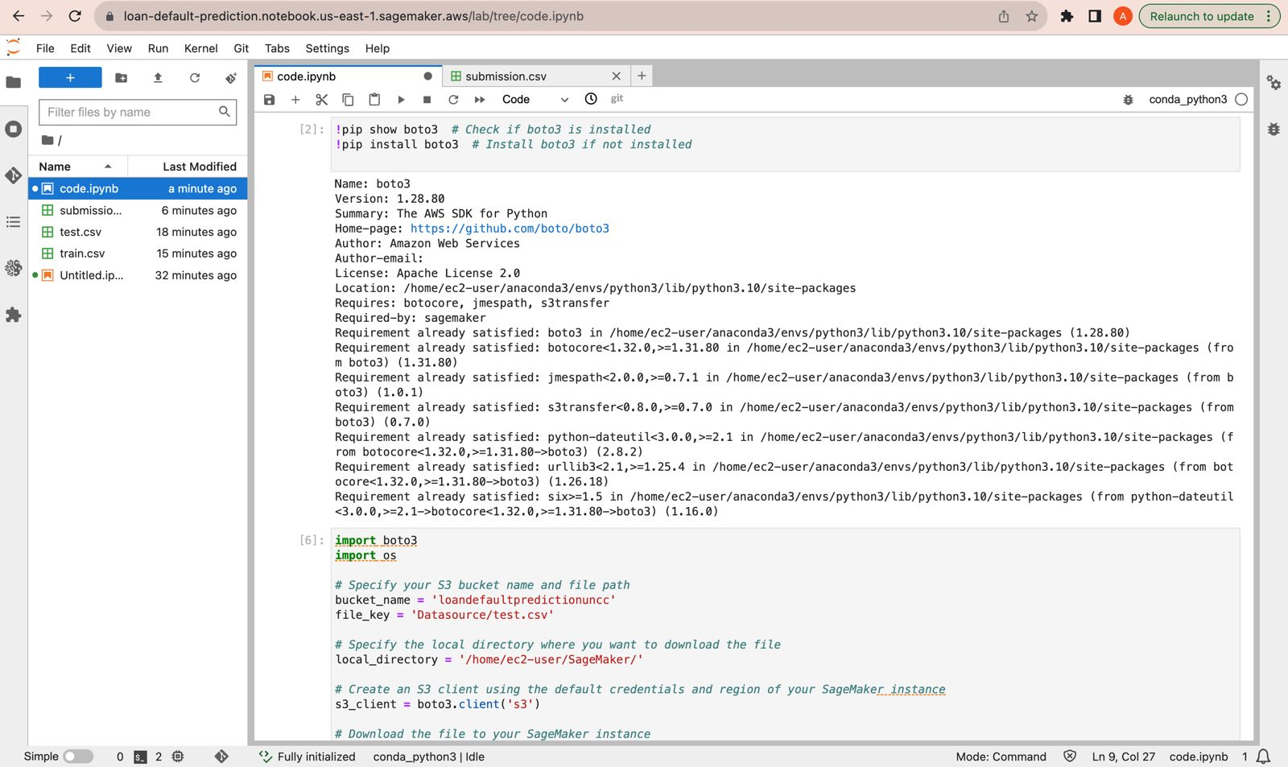

Loading the data from the S3 bucket for evaluation and validation

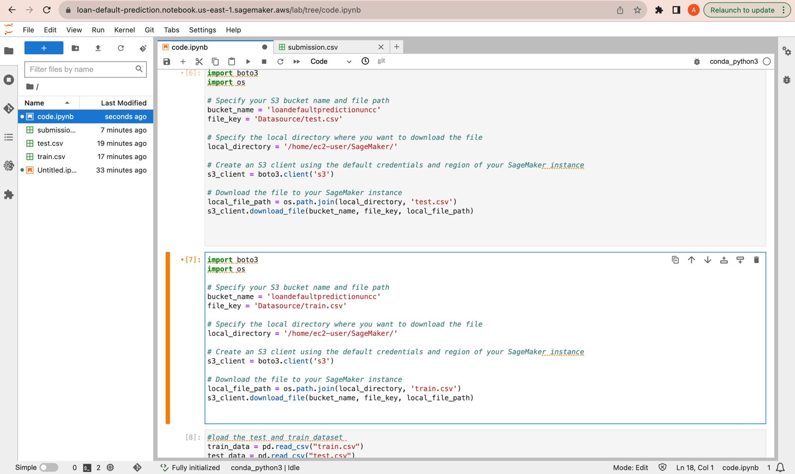

Checking the Train dataset by using head and dataset information

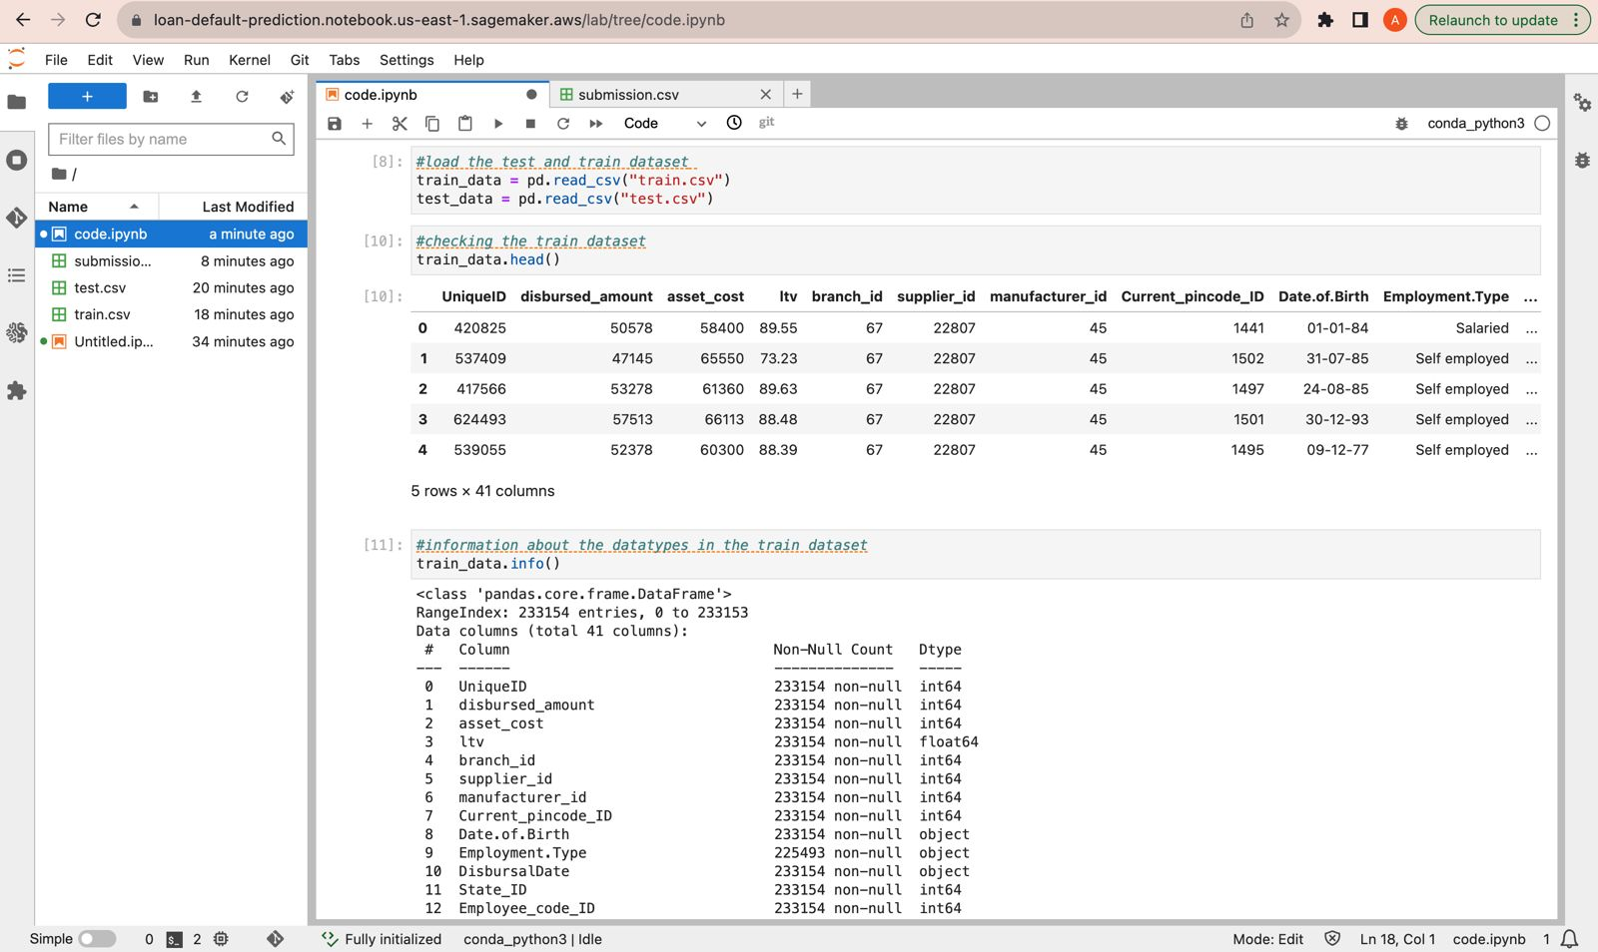

Train Dataset description and checking the test dataset by using head

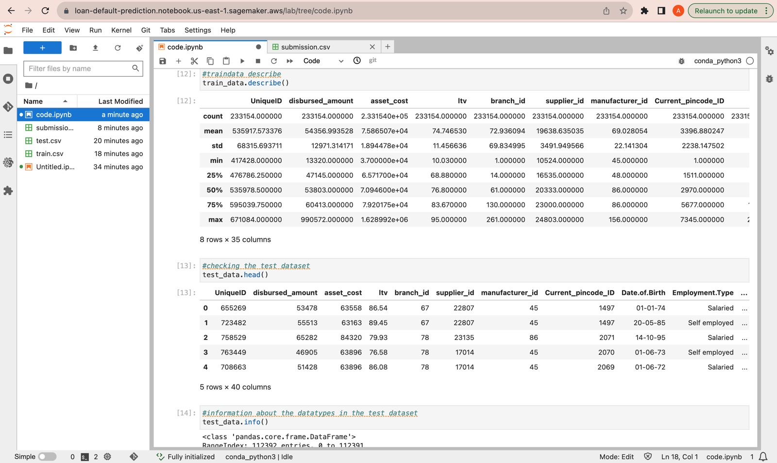

Test dataset information

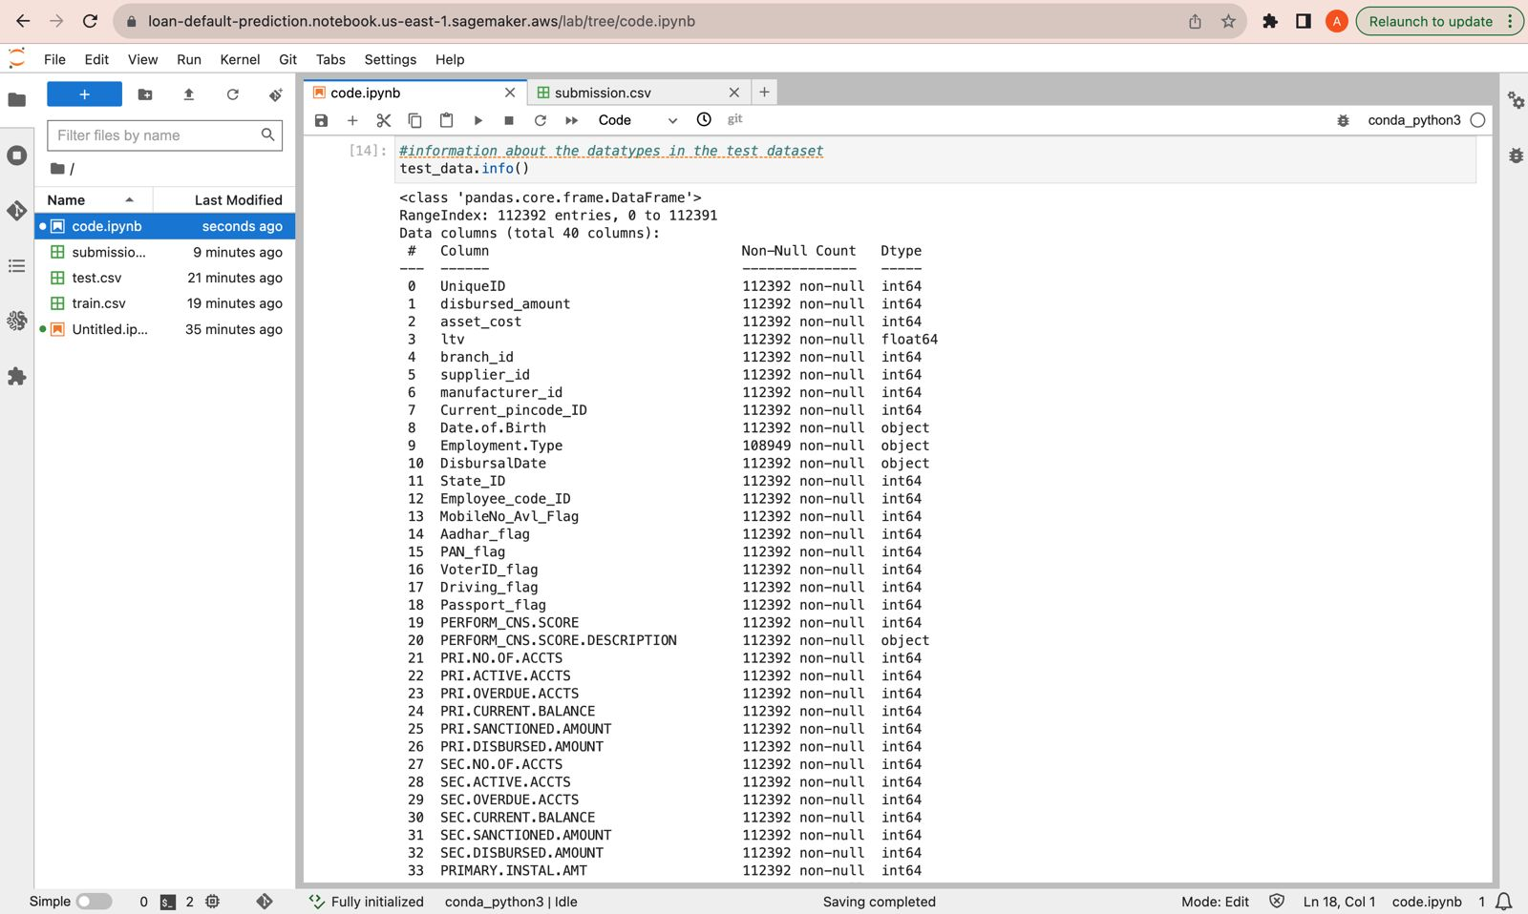

Test dataset description and Checking the null values in percentage for the train dataset

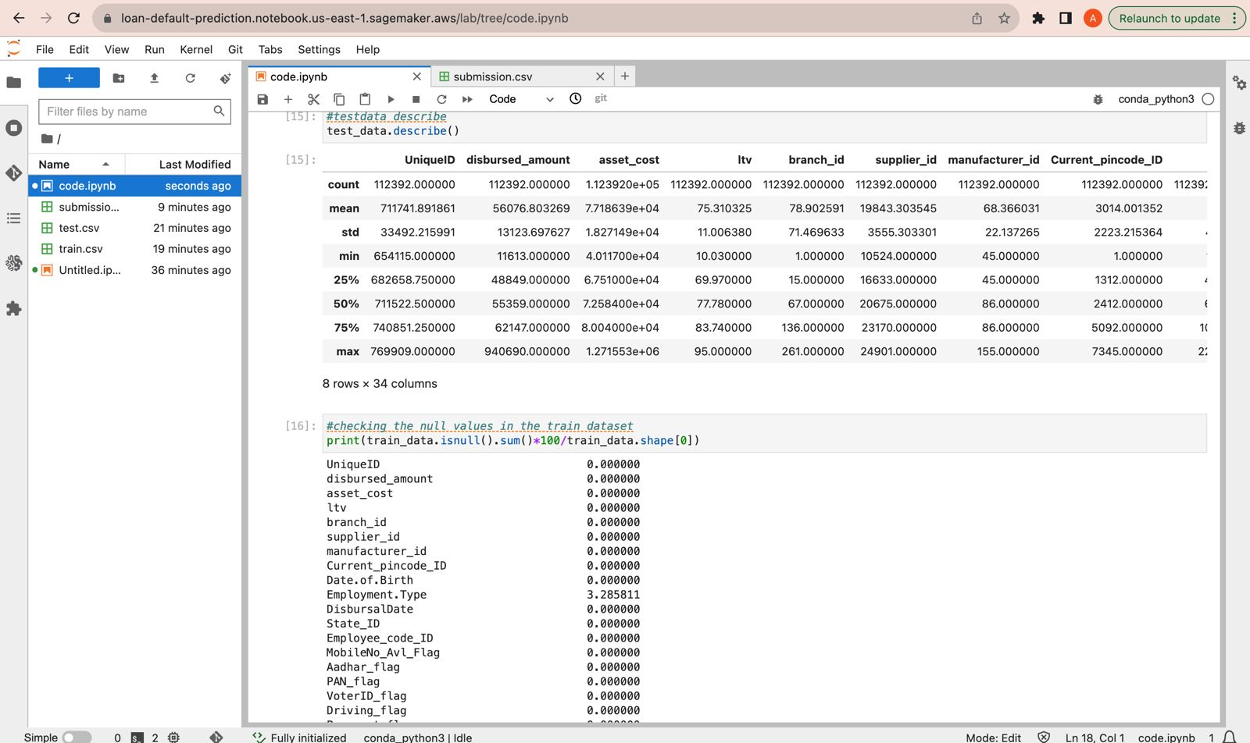

Checking the null values in percentage for the test dataset

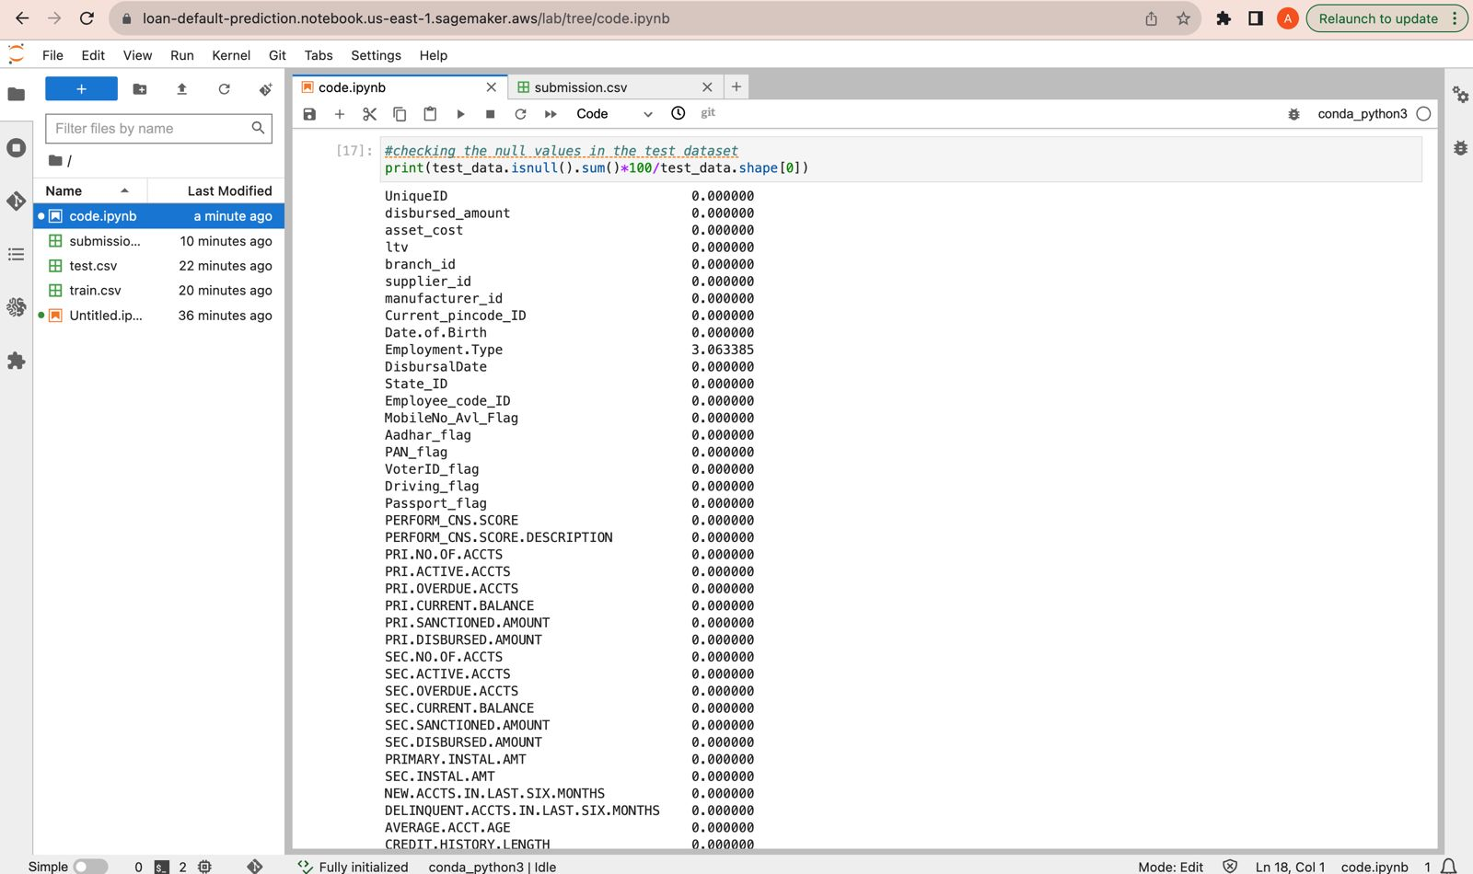

Eliminating the null values using the simpleImputer and Checking again whether other columns has null values for the train dataset

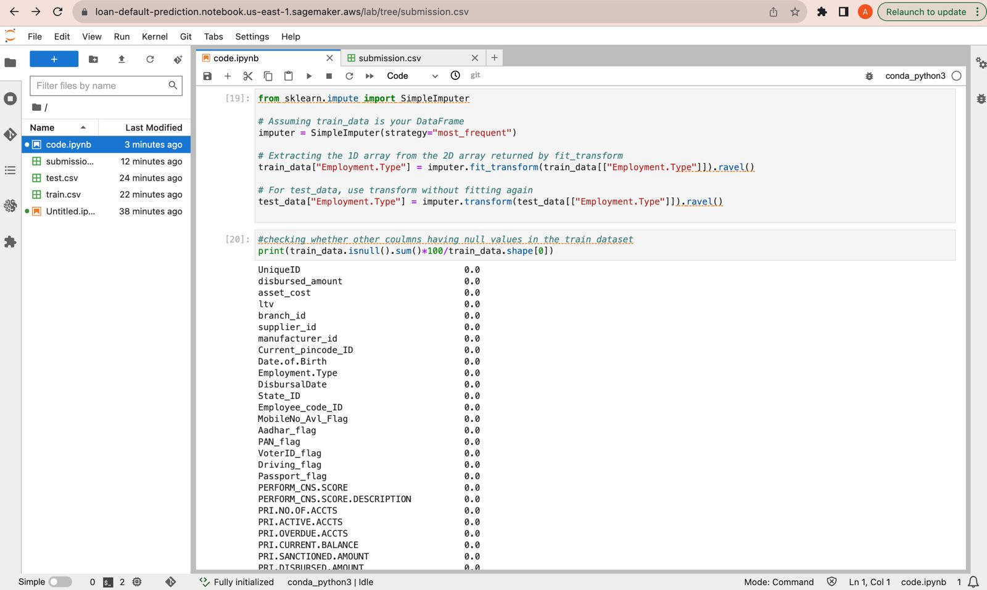

Checking again whether other columns has null values for the test dataset

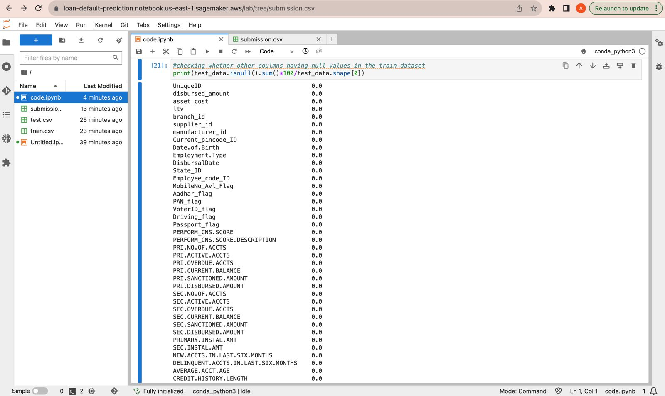

Encoding the categorial objects into values by using the label encoder.

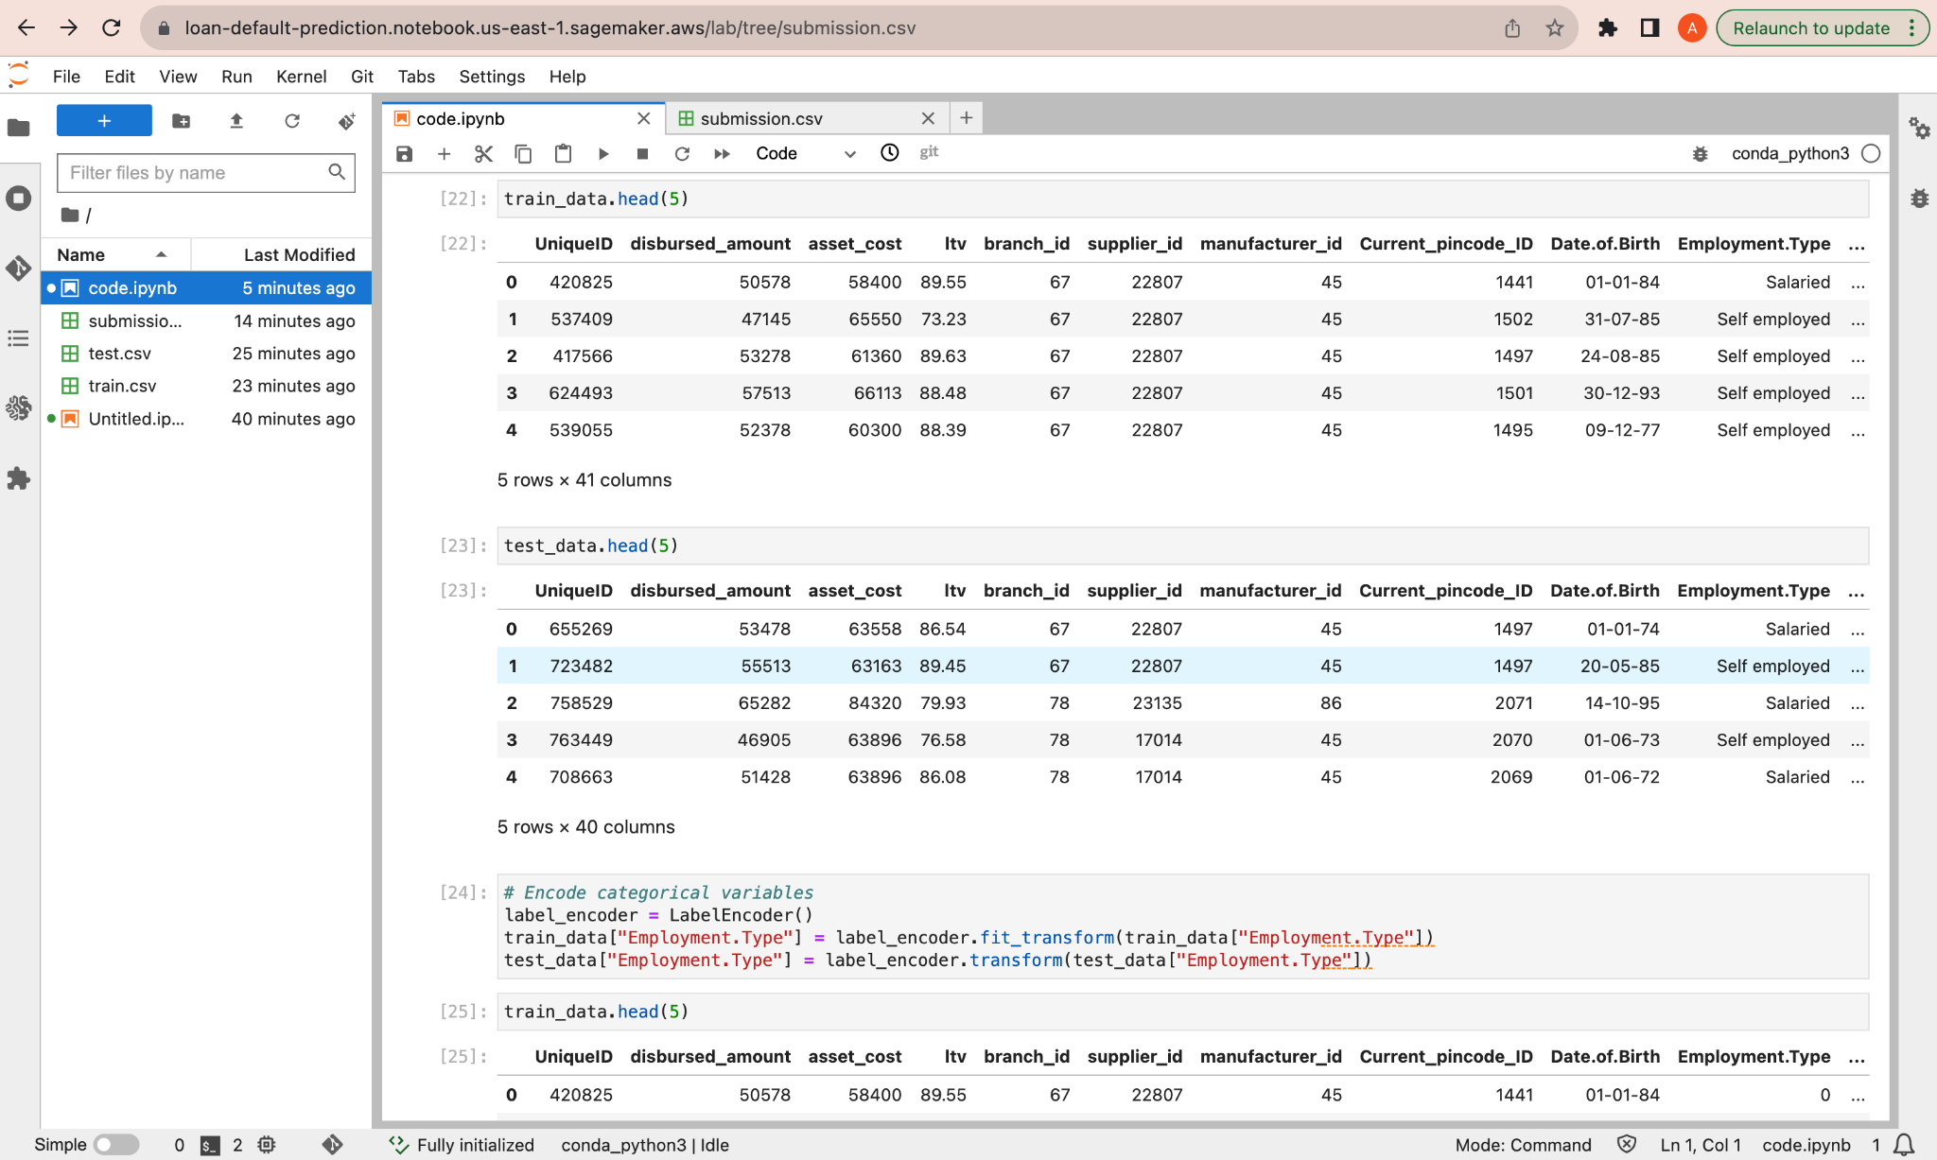

After conversion of categorical values and eliminating the outliers which effects the database, converting the date columns into the datetime objects

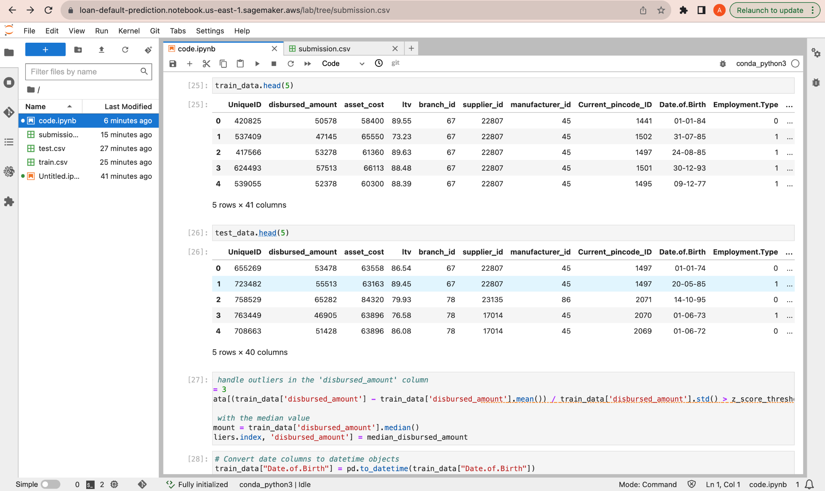

Handling the outliers and replacing them with their median values.

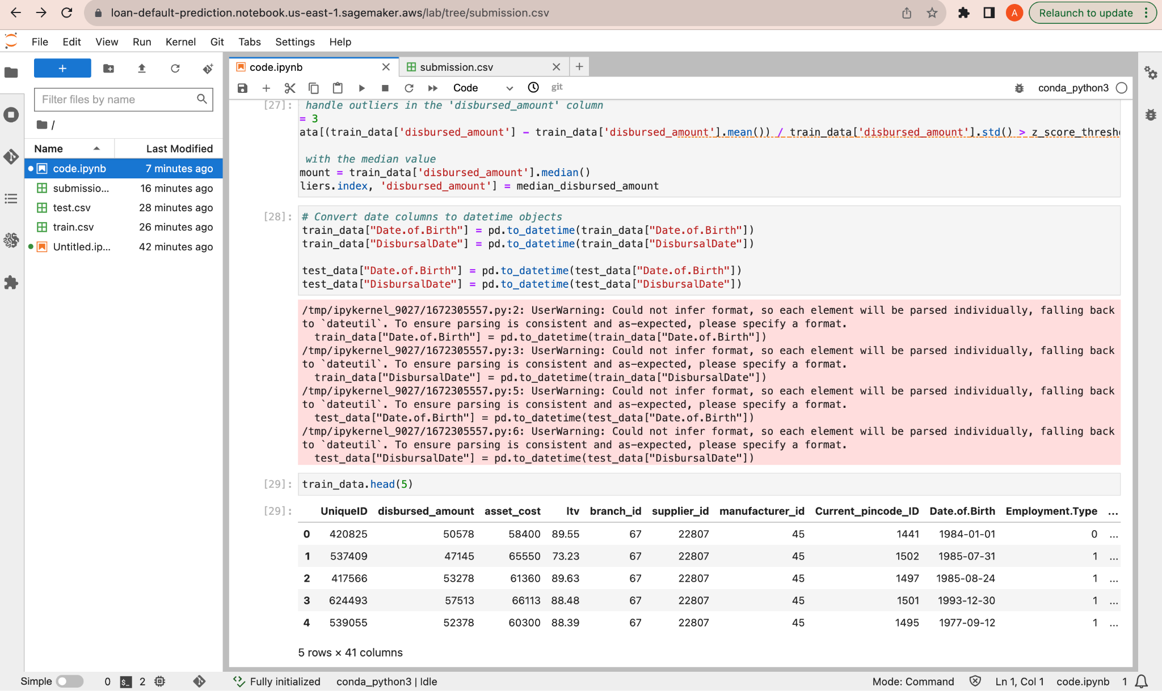

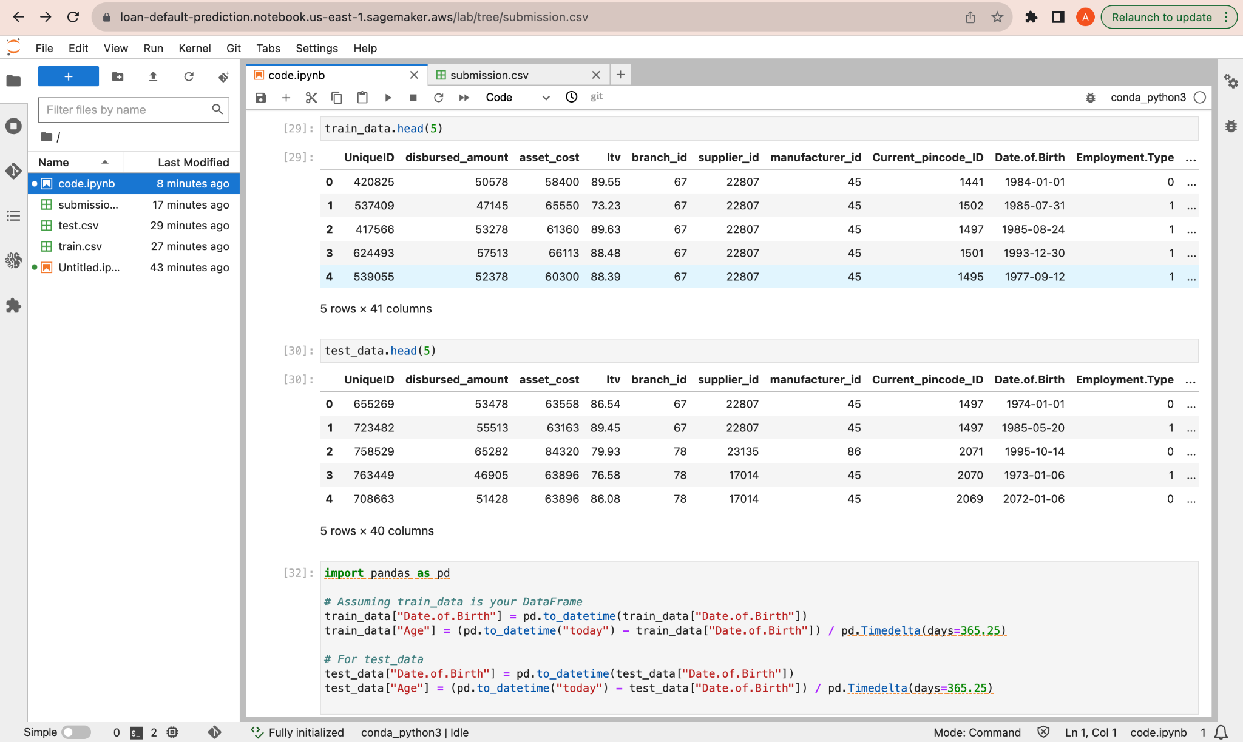

Creating the features, calculating the age in the test and training datasets.

Evaluating the model by using the random forest techniques and predicting the values.

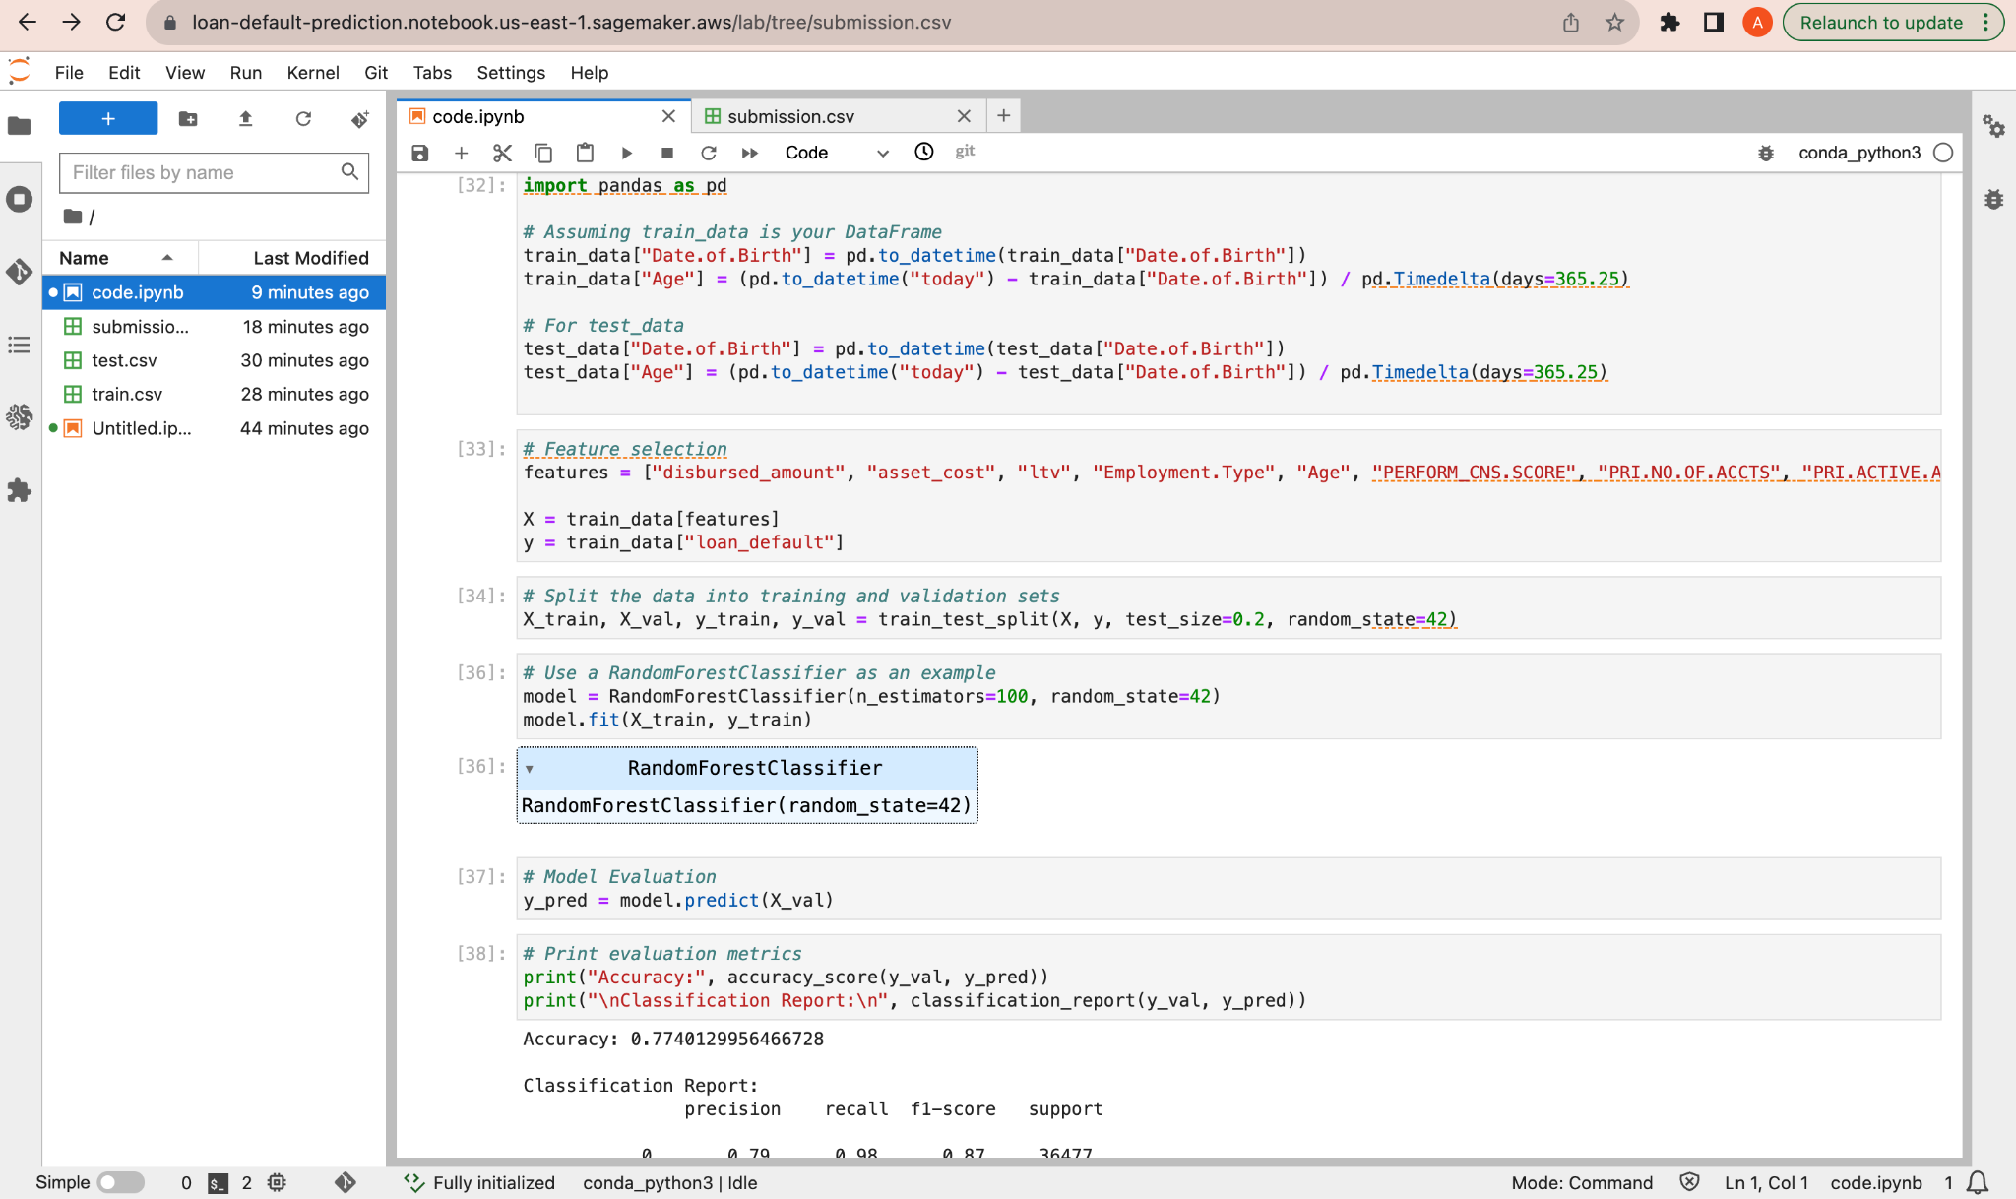

Evaluation matrix

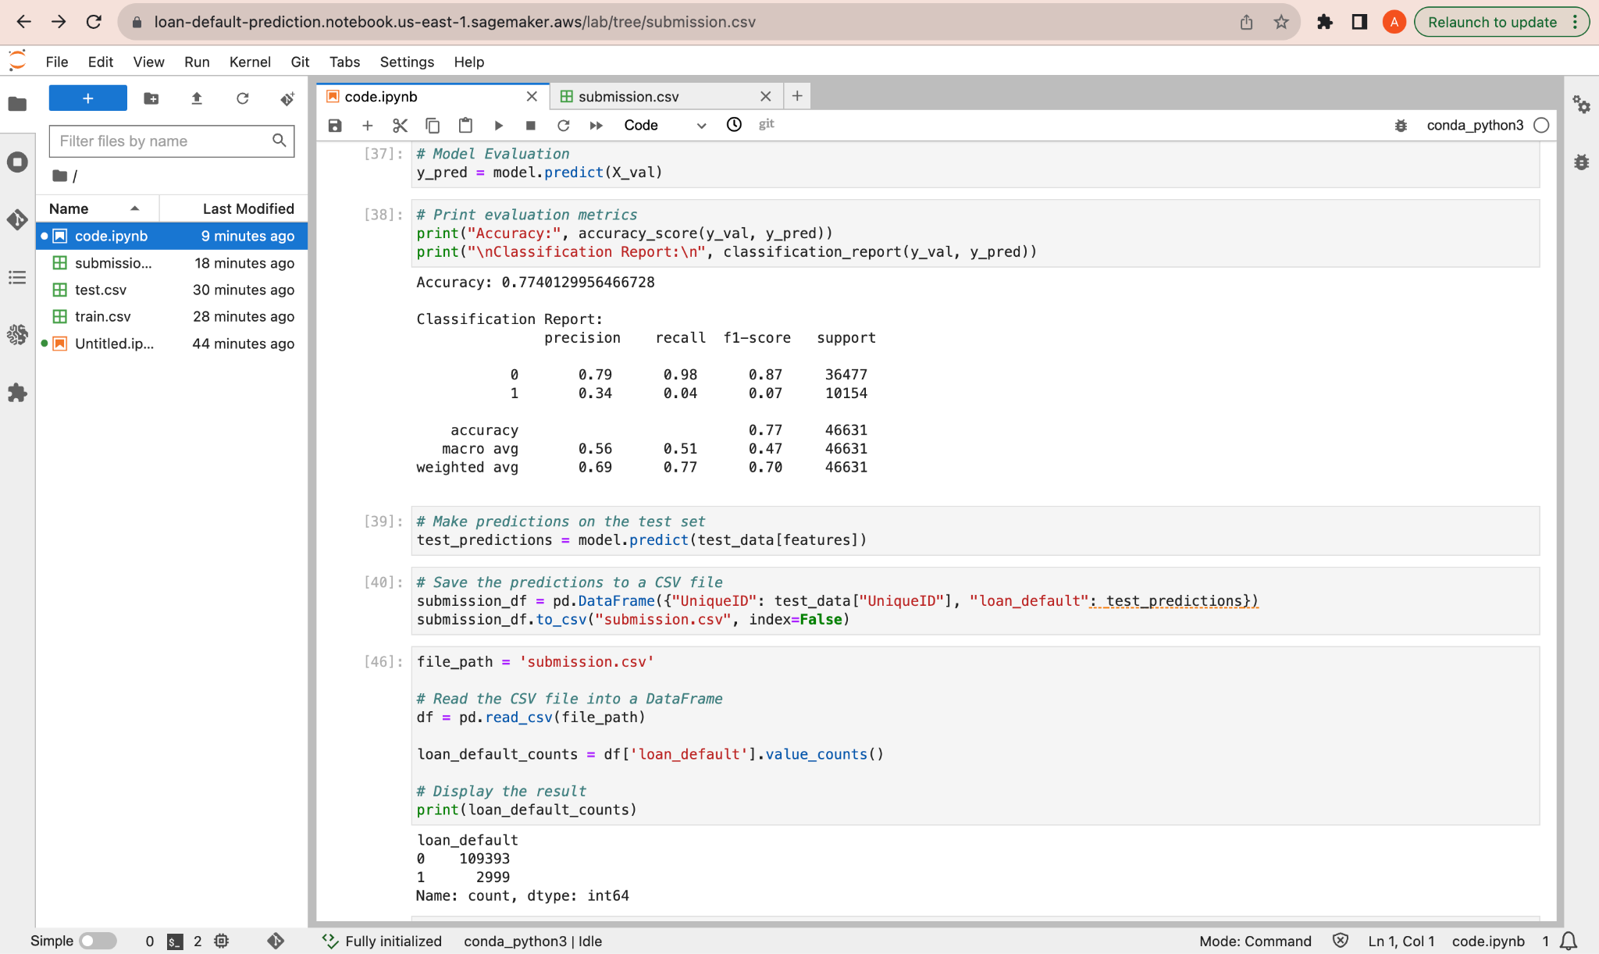

Heatmap visualization correlations between the columns

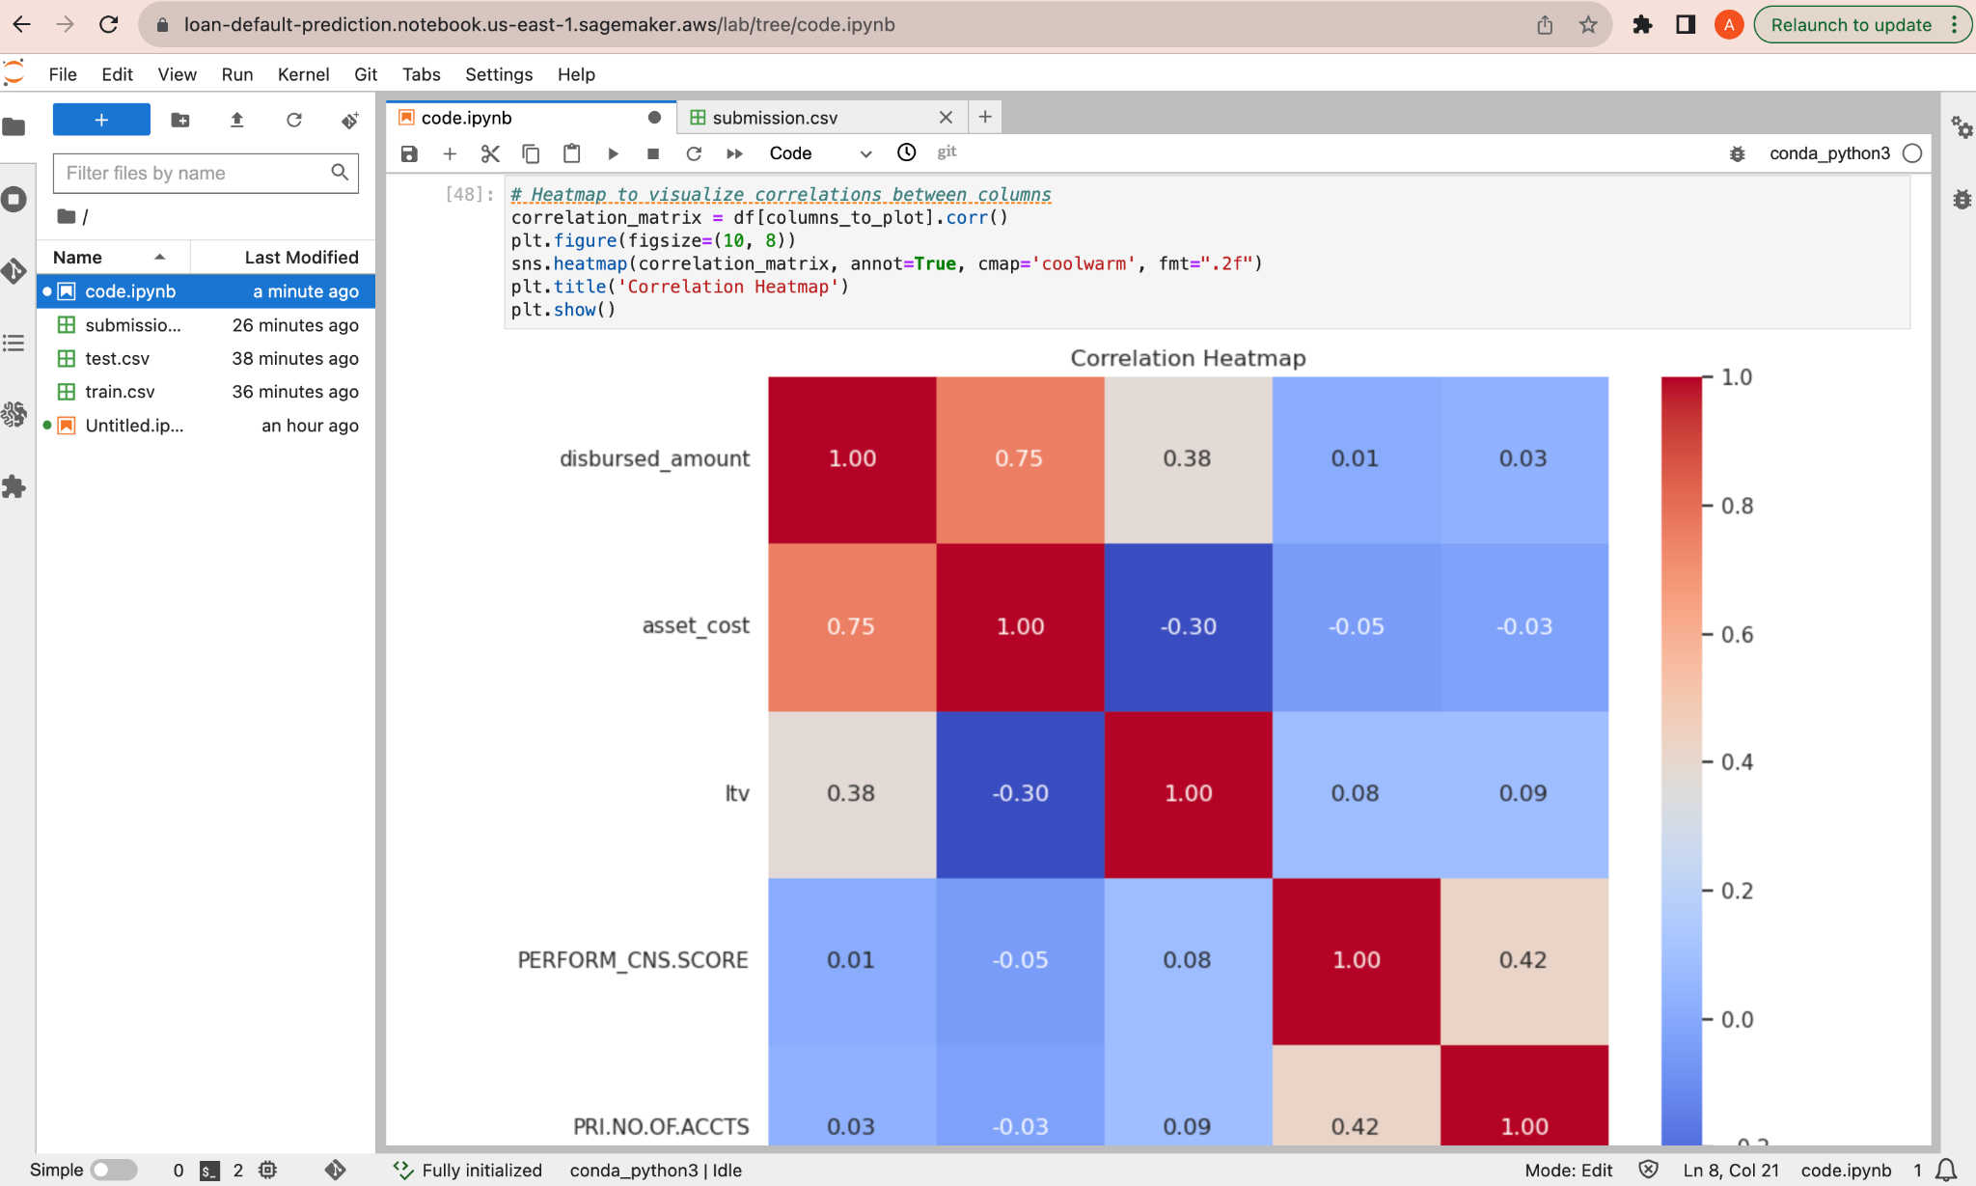

Data analysis with scatter plot

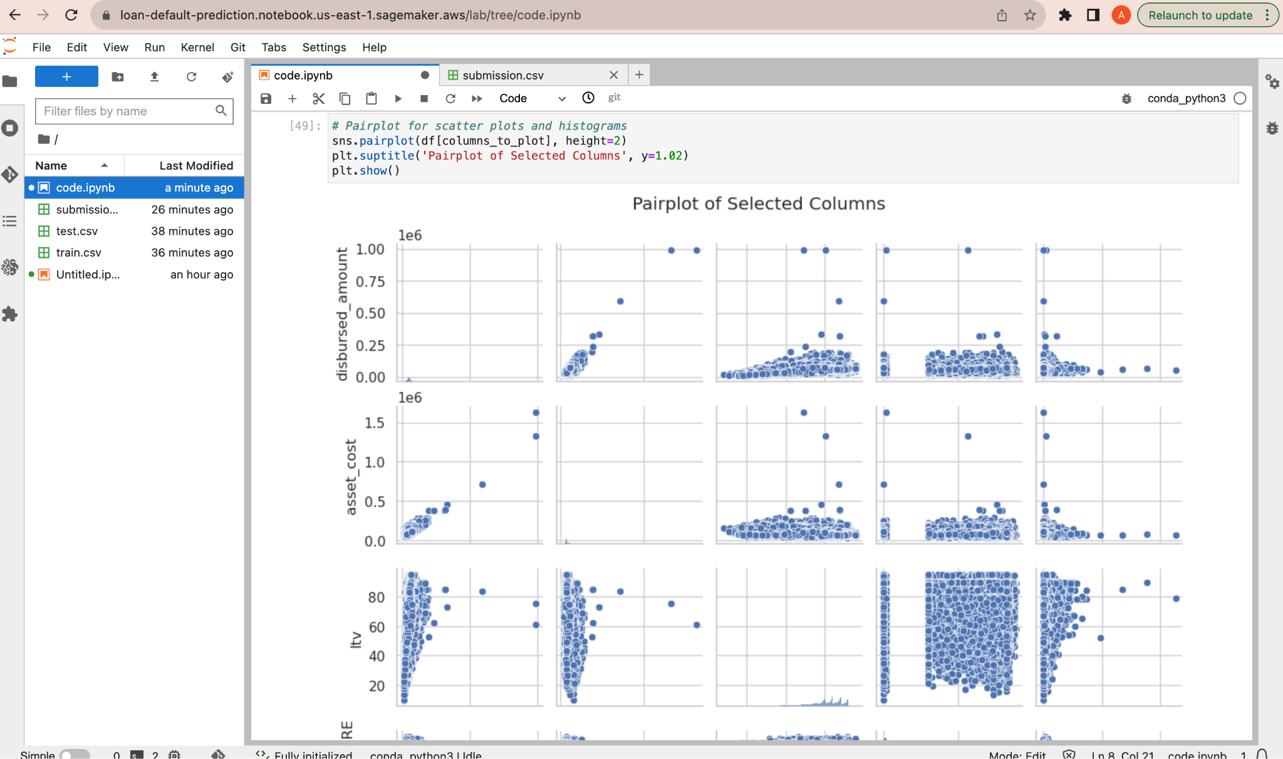

Data analysis with Boxplot

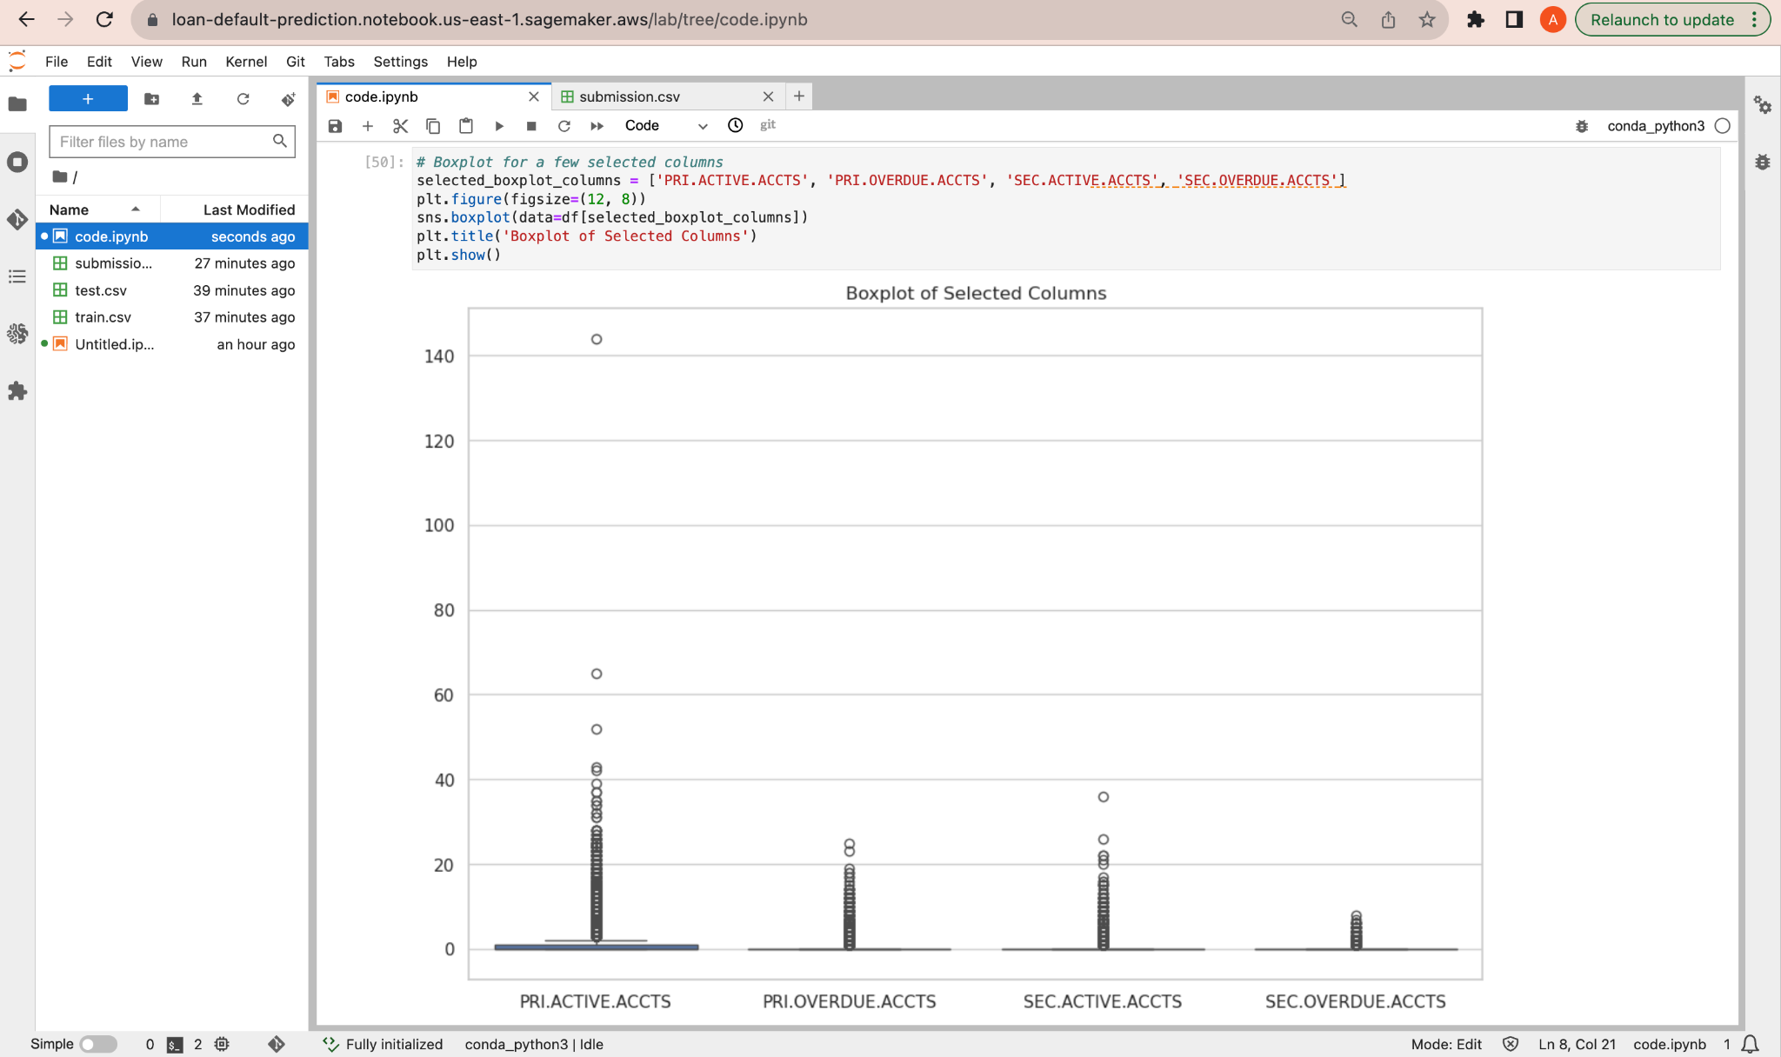

Data analysis with Barchart

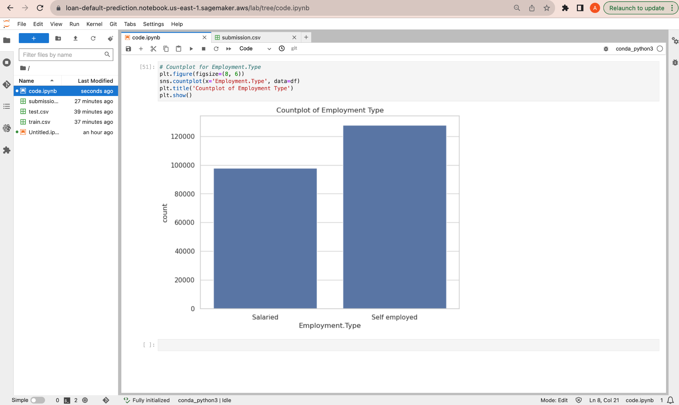

QuickSight - Link to access the visualizations - <https://us-east-1.quicksight.aws.amazon.com/sn/accounts/501723330586/dashboards/f56f7308-4ef9-4cef-8282-0509cc19972c?directory_alias=nullrr>

Linechart

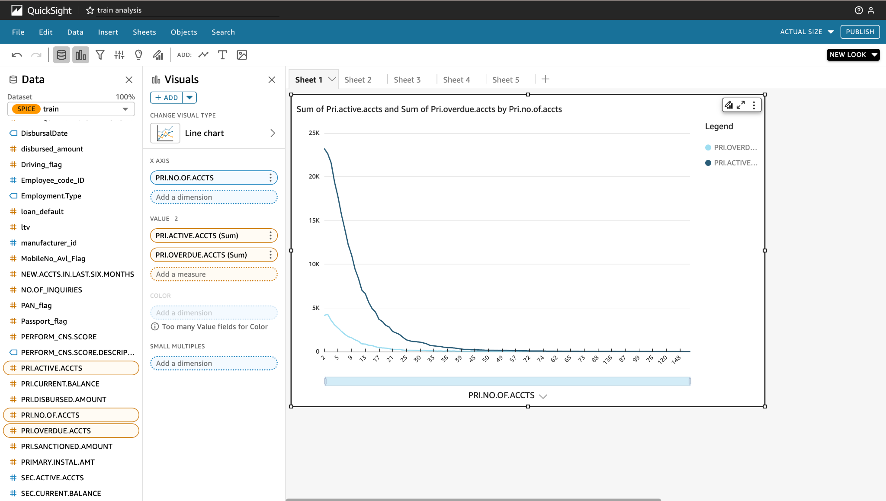

Areachart

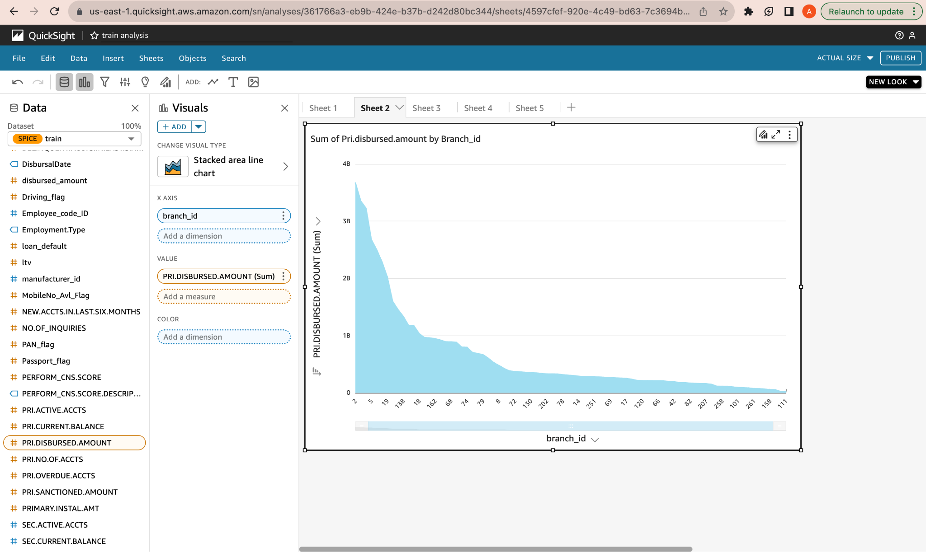

PieChart

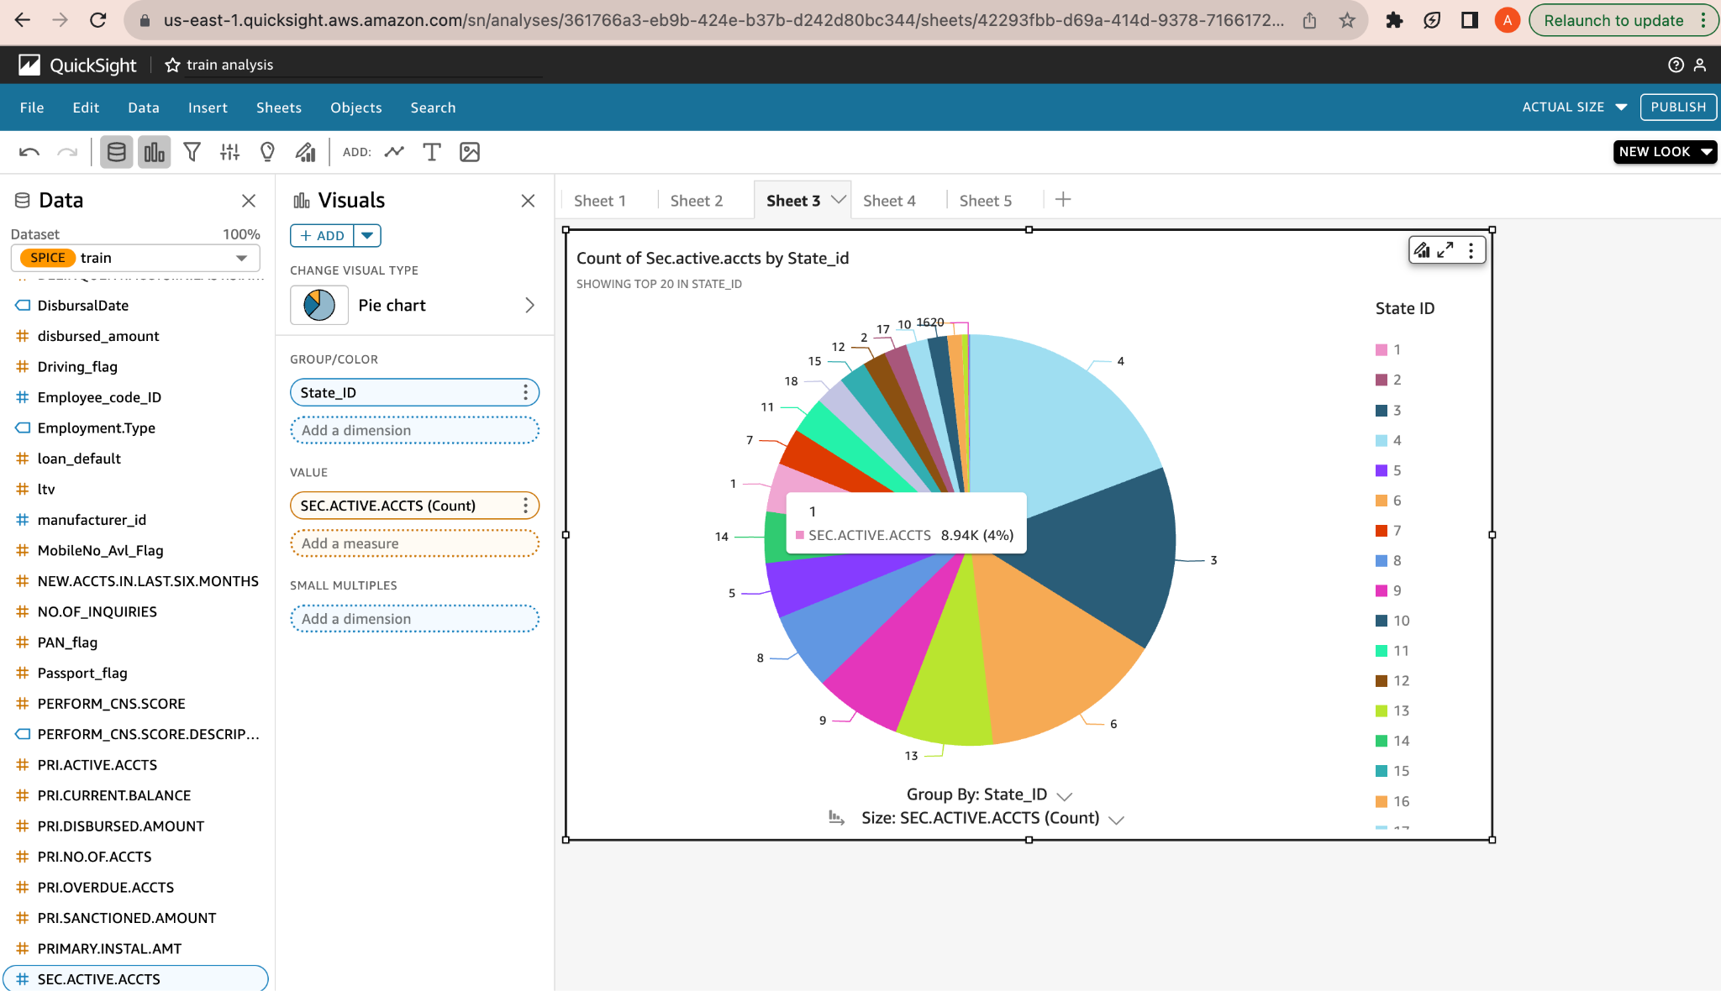

TreeMap

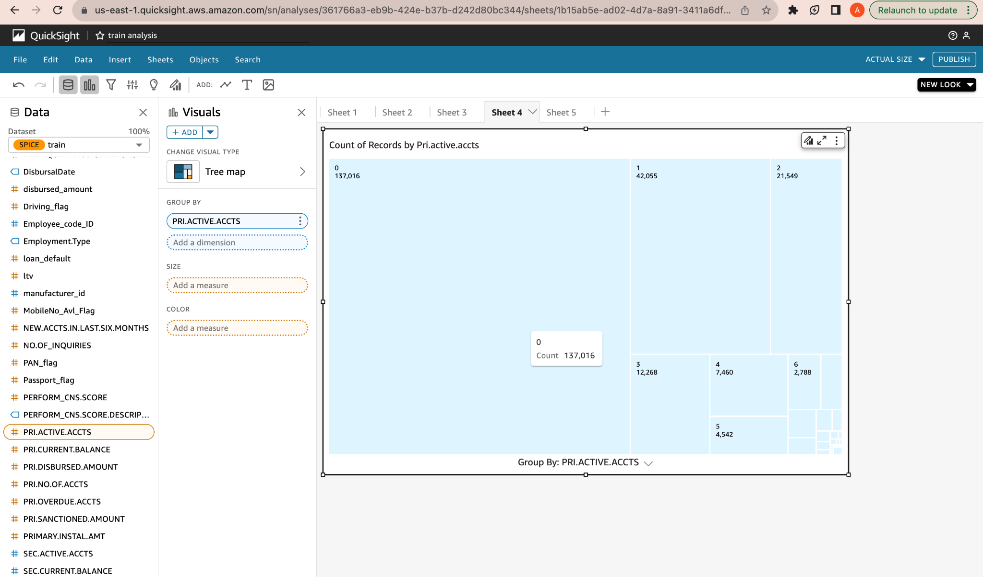

Vertical Barchart

